Understanding the Impact of Adverse Childhood Experiences to
Support Healing and Promoting Resilience

Midcoast First Responders Professional Development
May 4, 2022
12:00-1:30 PM
Training conducted by Maine Resilience Building Network

We know from the research, that there’s a strong correlation between adverse childhood experiences, ACEs (which are common), and mental, emotional, and behavioral health issues. Preventing and healing ACEs is possible through building core protective systems such as resilience.
Participants will understand the foundations for resilience and learn trauma informed strategies that can be applied in community to help promote resilience. The neuroscience will be reviewed providing participants with a model for understanding the nervous system and emotion regulation.
Anxiety, mental health issues and opioid use have risen in our culture. In the midst of suffering, people continue to report feeling judged and stigmatized by providers.
We will expand our awareness, widen our perspective and unlearn judgment without being hard on ourselves. Guided by science, empathy and a trauma-informed lens, we’ll debunk myths and begin moving away from “us versus them” toward a vision that “we” can heal together.

Join Zoom Meeting
https://us02web.zoom.us/j/7040215445
Meeting ID: 704 021 5445

For questions: Contact Elizabeth Wiest, elizabeth.wiest@mainehealth.org

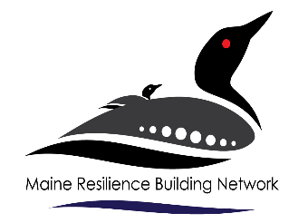
Sponsored By:

