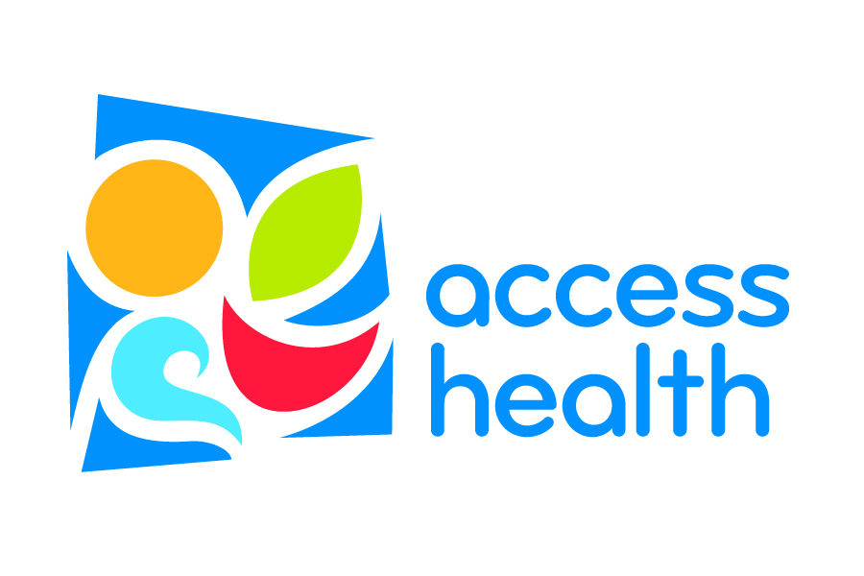
Marijuana Legalization
Public Health Considerations & Municipal Options
This brief provides the potential public health impact of increased access to marijuana based on experiences of states that have legalized, public health research, and best practice recommendations. Included are public health concerns, best practices from tobacco and alcohol regulation research, and potential strategies local municipalities could adopt to ensure best practices are being implemented locally.
Public Health experts have identified five main public health concerns of legalized marijuana that could be addressed through regulation:
- Youth access and increased use
- Impaired driving
- Dependence and addiction
- Unwanted contaminants
- Concurrent use of marijuana and alcohol.
All these concerns, and potential regulation options, are summarized on pages 3-6. We have highlighted and provided more information on youth access and use below, which is our primary public health concern.

Youth Access & Increased Use
Marijuana Use Rates: Brunswick
 | Brunswick High School | 7th & 8th grade
Ever tried marijuana | 29.2% | 5.7%
Used marijuana in past 30 days | 14.7%  (lower than state average) | 2.7%
Report Marijuana is “easy to get” | 50.8% | 13.7%
Feel regular marijuana use  is “not risky” | 55.6% | 26%
Maine Integrated Youth Health Survey, 2015. Unless indicated, all rates are at state average.

Research has identified several youth beliefs that influence use of alcohol, tobacco and marijuana. Access and belief of harm are strong predictors of youth use. Youth who report substances are easy to get or believe that use is not risky are more likely to also report using that substance in the past 30 days. Legalizing marijuana may result in an increase in youth access and a decrease in the belief of harm. The following regulatory strategies have been proven to successfully limit youth access and combat low belief of harm of tobacco and alcohol, and could be duplicated to limit youth access and use of marijuana:
  - Higher prices - taxes, minimal prices, limiting promotions/sales
  - Licensing and monitoring of retailers – limit licenses/density of shops, required retail trainings & regular compliance checks
  - Limiting marketing – including outside and inside signs, and packaging/labels
  - Limiting types of products sold – youth are attracted to marijuana edibles, such as edibles that resemble candy, baked goods, soda, etc.
  - Restricting public consumption – reduce normalizing of behavior
  - Preventing social access – clear and enforced furnishing regulations, e.g. providing the substance or place to consume the substance
.

Access Health is a community health coalition serving
Sagadahoc County, Brunswick and Harpswell
www.AccessHealthME.org

Legalized Marijuana: Public Health Concern and Regulation Best Practices
- Research has found that increased access to a substance leads to increased use among youth and adults. It is important to establish strong policies and regulations from the outset to decrease negative public health consequences of increased use.
- Public health concerns of increased access to marijuana include: increased youth access & use, drugged driving, dependence and addiction, unwanted contaminants and uncertain potency of products, and concurrent use of marijuana and alcohol.
- The regulation best practices outlined below have been effective in preventing the public health concerns marked with a check, and could be adopted to regulate marijuana. Pages 3-4 outline methods used nationally to implement these best practices; if and how the current state statute meets this regulation recommendation (NOTE – the state has not finalized regulations); and options municipalities could adopt to strengthen state regulations.

Public Health Concerns
(A “” below indicates that the public health concern can be effectively addressed by the regulation option listed on left)
Regulation Best Practices | Youth Access & Use | Impaired Driving | Dependence and Addiction | Unwanted contaminants and uncertain potency | Concurrent use of marijuana and alcohol
- Increase prices
- Restrict and carefully monitor licenses and licensees
- Limit marketing
- Limit types of products sold
- Restrict public consumption
- Measure and prevent impaired driving
- Prevent social access by youth

Regulation Best Practice | How?  Methods used to regulate  alcohol or tobacco | Current Statute  (as passed, does not reflect changes adopted since 11/2016) | Options for Municipalities  Prohibiting retail sales is an option
Increase prices | - Excise taxes  - Fees  - Limit production licenses | - Sales tax 10%  - State cannot fix prices | - Increase taxes or fees to be in line with other states or municipalities  - Adopt minimum pricing requirements
Restrict and carefully monitor licenses and licensees | - License EVERY part of supply chain  - Keep number of licenses low – lower cost to regulate  - Restrict density and location  - Restrict modes of sales (e.g. no vending machines or self-service)  - Restrict hours of operation  - Restrict goods that can be sold | - Licenses at every supply chain required  - Training of officers required  - State cannot limit licenses  - Only MJ, accessories, non-consumables allowed at stores  - No vending machines  - Municipalities must approve all licenses, can restrict, limit or prohibit licenses  - Can have local licensing requirements  - MUST card | - Regulate like alcohol:  - Require & conduct regular compliance checks (law enforcement must be trained)  - Adopt license revoking ability for illegal sales  - Adopt illegal sale consequence/fine for both clerk & licensee  - Require Responsible Marijuana Licensee trainings of all retailers and clerks to cover law and best retail practices (such as current alcohol licensee trainings)  - Ensure regular inspection of supply chain (retail, grow, testing & manufacturing/production)
Limit marketing | - Ban:  - Advertising – print, television, radio, etc.  - Promotions: Price discounts, coupons, free samples  - Sponsorships  - Indirect – merchandise  - Retail displays  - Require plain packaging | - Limits on retail displays required - TBD  - Limits on marketing required, must not appeal to youth - details TBD  - No mass marketing allowed  - No packaging implying it is a trademarked food product  - 21 to purchase, not to enter  - Personal – must restrict access by under 12 | - Have clear, strict marketing guidelines – especially for edibles  - Prohibit unaccompanied minors from shops  - Restrict signs and advertising – especially for advertising that can be viewed from outside the store  - Density guidelines: restrict number of licenses and/or location (not within school or youth serving agency zones)

Regulation Best Practice | How?  Options used to regulate  alcohol or tobacco | Current Statute  (as passed, does not reflect changes adopted since 11/2016) | Options for Municipalities  Prohibiting retail sales is an option
Limit types of products sold | - Limit:  - What’s allowed in the product (additives, flavorings)  - Methods of production (pesticides, mold, contaminants)  - Bundling with other inputs (edibles, nicotine)  - Anything that appeals to youth – candy, sodas, etc. | - THC limit per serving -TBD  - Testing of product required to prevent contaminants  - Labeling, including THC levels, THC per serving, number of servings & warning labels  - Retail and social clubs allowed, restricted to marijuana use only  - No additives designed to make product more appealing to children allowed | - Allow only single serving edibles  - Require child proof packaging  - Adopt strong definition on what “appeals to children”
Restrict public consumption | - No public place where youth could see or non-user would be exposed | - The prohibitions and limitations on smoking tobacco products in specified areas apply to smoking marijuana.(Marijuana is included in smoking laws; Title 22, chapters 262 and 263) | - Adopt and enforce public consumption fines  - Prohibit or restrict social clubs
Measure and prevent impaired driving | - Adopt strict OUI limit  - Mandatory fines  - Sobriety check points  - Media campaigns –best practice, tested messages  - Active, visible enforcement | - Tax revenue to general fund; cannot directly fund new programs but it may be appropriated to the Maine Criminal Justice Academy  - For training law enforcement personnel on retail marijuana and retail marijuana products laws and rules.  - Funds can only be used for training and education of law enforcement personnel. | - Ensure law enforcement is trained and prepared, with reliable testing resources and budget for OUI details  - Prohibit social clubs
Prevent social access by youth | - Strict furnishing and social hosting laws  - Parental monitoring campaigns | - No public health or communication funding included | - Adopt and enforce strict furnishing laws mirroring alcohol (furnishing or a place to consume)  - Funding to law enforcement and education campaigns to implement effective strategies: “party patrols”, parental monitoring and furnishing awareness campaigns
References:
Rosalie Liccardo Pacula, Beau Kilmer, Alexander C. Wagenaar, Frank J. Chaloupka, Jonathan P. Caulkins, “Developing Public Health Regulations for Marijuana: Lessons From Alcohol and Tobacco”, American Journal of Public Health June, 2014): pp. 1021-1028.
U.S. Department of Health and Human Services (HHS), Office of the Surgeon General, Facing Addiction in America: The Surgeon General’s Report on Alcohol, Drugs, and Health. Washington, DC: HHS, November 2016.
Recreational Marijuana in Maine: https://legislature.maine.gov/9419: A summary of the statute language, legalization committee, federal legislation, and related news.

Access Health is a community health coalition serving Sagadahoc County, Brunswick and Harpswell
www.AccessHealthME.org

